Accessing Customer Statements from the Client Service Portal

Access the Client Service Portal: https://csp.carlile.biz/index.msw
If you have not yet registered, please email CustomerService@Carlile.biz to request access.
If you have already registered, click on the Login link to enter your user name and password.

On the home page after logging in, click on Customer Reports.
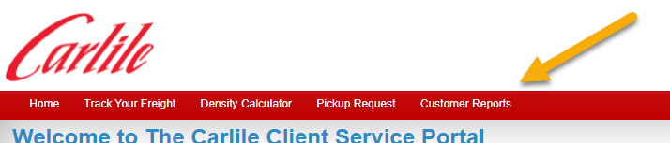

Next, click on Customer Statements.
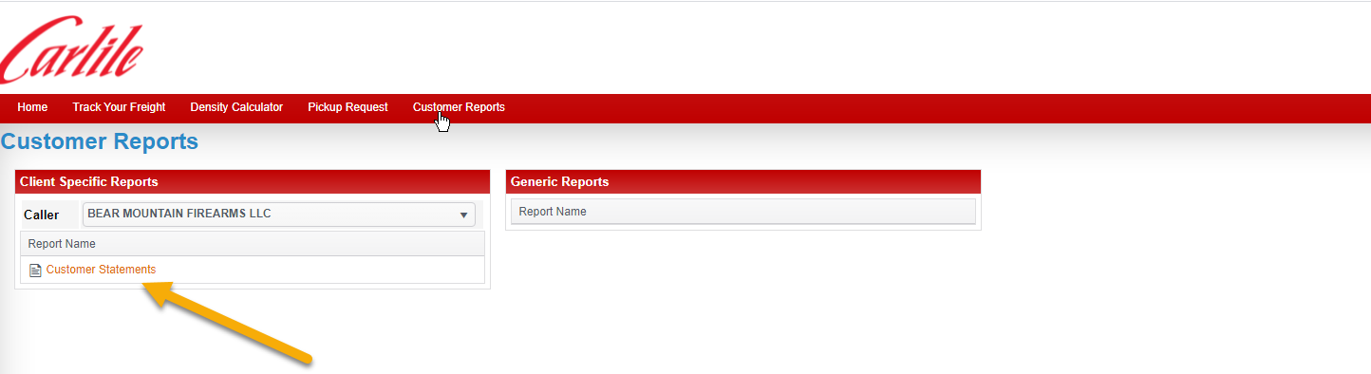
This icon will be displayed while the report is loading. This does take a little time. The report view window will open.

The window can be made resized by hovering over the edge of the window until the cursor becomes a double arrow. Then right click and drag the edge to desired size.
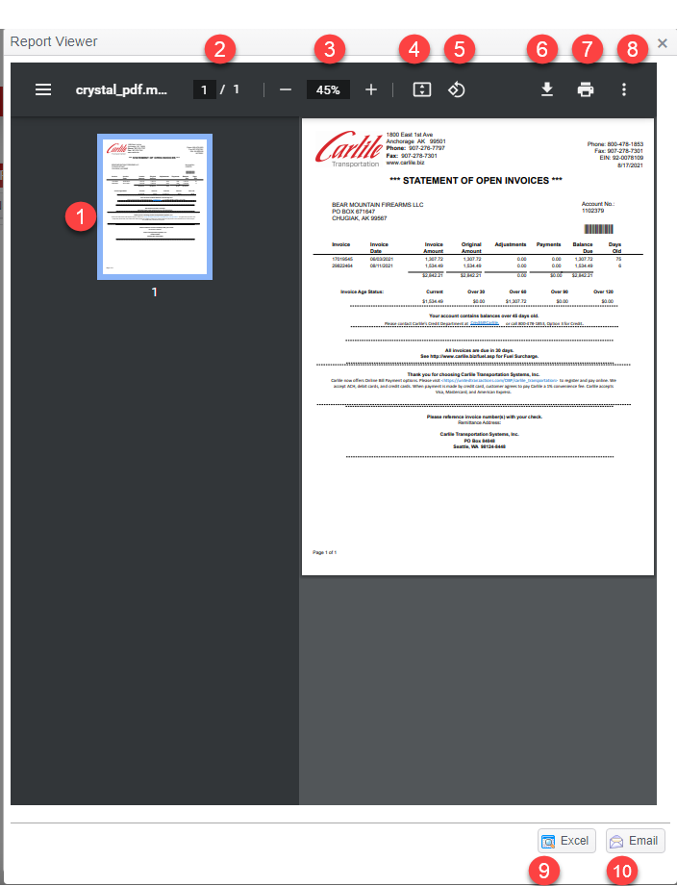
- Thumbnail display of the report.
- Current page/Total pages.
- Magnification click on the – to reduce the image. Click on the + to increase the image. The % will increase or decrease depending on if you select – or +.
- This icon will cause the image to increase to fit the window top to bottom.
- Allows user to rotate the image 90 degrees.
- Allows the user to down load the Statement.
- Allows the user to print the statement.
- Gives the user more options.
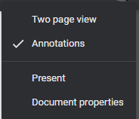
- Export to Excel
- Send the statement in an email.

